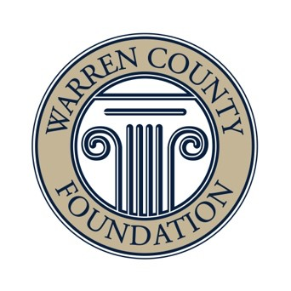
Subject: A Leadership Update from the Warren County Foundation

November 3, 2025
Dear Friends,
I’m honored to share that I was recently elected to serve as Chair of the Warren County Foundation Board of Trustees at our October Annual Meeting. Having served on the Board and Executive Committee for many years, I’m deeply committed to the Foundation’s mission and to the trust you place in us.
Together with Interim President & CEO Mike McGinty and Chief Financial Officer Tim Nusbaum, I’m helping to oversee the completion of our comprehensive reconciliation process with Brixey & Meyer, our independent accounting partner. This thorough work— now nearing conclusion—remains central to our shared commitment to transparency, accountability, and strong stewardship.
We are also grateful to Dale Brunner, who will continue to serve as Immediate Past Chair and a member of the Executive Committee, ensuring continuity and partnership during this transition. Meanwhile, our mission-driven work continues: grants are being awarded, community partnerships are thriving, and the Foundation remains steadfast in its commitment to improving the quality of life in Warren County.
If you have any questions or would like to connect, please don’t hesitate to reach out to me at 513.383.2755 / maggi6195@yahoo.com. or
Mike McGinty at 513-265-6546 / mmcginty@warrencountyfoundation.org.
We welcome your thoughts and value your continued partnership.
Thank you for your continued trust and belief in the power of community philanthropy.

With gratitude,
Maggie Hess
Chair, Board of Trustees

